**Smart Home Automation System**

A Project Report submitted to the

Department of Electrical and Information Engineering

Faculty of Engineering

University of Ruhuna Sri Lanka

On the 18th of March 2025

In completion of the module

EE6352 Embedded Systems Design

By

Surasinghe R.L.D.T.H. - EG/2021/4820

Tharshihan R. - EG/2021/4825

Jackshan Venujan G.S. - EG/2021/4566

Dinojan V. - EG/2021/4487

**Table of Contents**

1. INTRODUCTION 4

1.1 Introduction to the problem 4

1.2 Literature review 4

1.3 Methodology overview 5

2. OBJECTIVES AND SCOPE OF THE PROJECT 6

2.1 Objective of the project 6

2.2 Scope of the project 6

3. SPECIFICATIONS 7

3.1 Automatic fan speed control 7

3.2 Automatic light control 7

3.3 Emergency power response in critical situation 7

4. SYSTEM MODEL OF THE PROJECT 8

4.1 System block diagram 8

4.2 Detailed specification 9

5. FINAL PRODUCT 14

5.1 Circuit diagram 14

5.2 Flow chart 15

5.3 Results and setup 16

6. DISCUSSION 18

6.1 Future Development Directions 18

7. REFERENCES 19

**Table of Figures**

Figure 4‑1: Block Diagram 8

Figure 4‑2: ATmega328P Microcontroller 9

Figure 4‑3 : KY-026 Temperature Sensor Module 9

Figure 4‑4 : MQ-2 Gas/Smoke Sensor 10

Figure 4‑5 : Liquid Crystal Display (LCD) 10

Figure 4‑6 : 5V Passive Buzzer 11

Figure 4‑7 : 18650 Lithium-Ion Batteries 11

Figure 4‑8 : One-Channel Relay Module 12

Figure 4‑9 : L298N Motor Driver Module 12

Figure 4‑10 : LED Lights 13

Figure 4‑11: 220Ω Resistors 13

Figure 5‑1 : Circuit Diagram in Proteus 14

Figure 5‑2: Flow chart 15

Figure 5‑3: Complete Project Layout 16

Figure 5‑4: LCD Display Output 16

Figure 5‑5: Arduino-Based Circuit Assembly 17

Figure 5‑6: A close-up view to the components 17

# 1. INTRODUCTION

## 1.1 Introduction to the problem

Home automation has become an essential aspect of modern living, enhancing convenience, energy efficiency, and safety. Traditional home systems require manual operation, leading to unnecessary energy consumption and potential safety hazards. One major challenge in households is the inefficient use of electrical appliances, such as fans and lights, which often remain turned on when not needed. Additionally, gas leaks pose a significant threat, as they can lead to severe accidents if not detected early.

The current reliance on manual control or basic automated systems limits efficiency and response time in emergencies. Many existing solutions lack intelligent decision-making based on environmental factors, leading to unnecessary energy waste and increased electricity costs. Furthermore, conventional safety measures depend on human intervention, making them unreliable in critical situations like gas leaks, where immediate action is required to shut down the power supply to prevent fire accidents.

To address these challenges, we propose a **Smart Home Automation System** that integrates sensor-based automatic fan speed adjustment, LDR based lighting control, and an emergency gas detection mechanism. The system will use environmental sensors to monitor temperature, ambient light levels, and gas leaks. Based on real-time data, it will adjust fan speed, control lighting, and trigger safety mechanisms in case of emergencies. This automation enhances energy efficiency, improves user convenience, and strengthens household safety.

By implementing this solution, we aim to create an efficient and reliable home automation system that minimizes energy wastage and enhances safety through smart, automated decision-making.

## 1.2 Literature review

Smart home automation has evolved significantly over recent years, becoming an essential aspect of modern living. According to recent research, the global smart home market is expected to reach $135 billion by 2025, driven by increased connectivity, AI integration, and sustainable solutions.

Current smart home systems face several challenges, including inefficient energy usage, manual operation requirements, and safety concerns related to gas leaks. Many existing solutions lack intelligent decision-making based on environmental factors, leading to unnecessary energy waste and increased electricity costs.

Various approaches exist for home automation systems, with sensor-based automation becoming increasingly popular for its reliability and cost-effectiveness. Temperature-controlled fan systems, light-dependent lighting controls, and gas detection mechanisms represent practical applications that address everyday household needs while enhancing safety and energy efficiency.

## 1.3 Methodology overview

Our methodology will follow a structured approach to develop an effective smart home automation system:

1. **Requirements analysis:** Identifying specific needs for temperature sensing, light detection, gas monitoring and alerting systems.
2. **System design:** Creating circuit diagrams and selecting appropriate sensors and components.
3. **Development:** Assembling the hardware components and programming the control logic
4. **Implementation:** Installing the system in a controlled environment
5. **Testing:** Conducting comprehensive testing of all three functionalities

# 2. OBJECTIVES AND SCOPE OF THE PROJECT

## 2.1 Objective of the project

The main objective of this project is to design, develop, and implement a **Smart Home Automation System** that enhances energy efficiency, convenience, and safety. The system aims to address the inefficiencies of manual control and the risks associated with gas leaks by automating key household functions.

Specifically, the system will:

* **Automatically adjust fan speed** based on temperature sensor readings to optimize cooling and reduce energy consumption.
* **Control room lighting** using an LDR sensor to ensure lights operate only when necessary, promoting energy efficiency.
* **Prioritize cutting the power supply** using the gas sensor upon detecting a gas leak, to prevent hazards, and trigger an emergency response.

## 2.2 Scope of the project

1. **Single-home automation**: The system is designed for individual household automation.
2. **Sensor-based automation**: The system relies on environmental sensors (temperature, LDR, and gas sensors) for automation.
3. **Power shut down using gas sensor data & relay**: The system immediately cuts the power supply upon detecting a gas leak, prioritizing safety and preventing potential hazards.

This scope ensures a **functional and efficient** smart home automation system while acknowledging its operational limitations.

# 3. SPECIFICATIONS

## 3.1 Automatic fan speed control

* The system should **monitor room temperature** using a temperature sensor.
* Fan speed should be **adjusted dynamically** using PWM control based on temperature variations.
* If the temperature exceeds a predefined threshold, the fan should automatically **increase speed**, and if it drops, the speed should decrease.
* For AC fans, the system should **switch ON/OFF** instead of adjusting speed.

## 3.2 Automatic light control

* The system should use an **LDR sensor** to measure ambient light levels.
* If the surrounding light level drops below a certain threshold, the system should **turn ON the lights automatically**.
* If sufficient natural light is present, the system should **turn OFF the lights** to conserve energy.

## 3.3 Emergency power response in critical situation

* The system should continuously monitor **gas concentration levels** using a gas sensor.
* If the gas concentration exceeds the safe threshold, the system should:
* **Trigger an alarm** to alert occupants.
* **Cut off the main power supply** using a relay to prevent fire hazards.
* **Display a warning indicator** for users.

This ensures the **Smart Home Automation System** operates efficiently by enhancing **energy savings, safety, and convenience** for users.

# SYSTEM MODEL OF THE PROJECT

## 4.1 System block diagram

Power Supply 2

Temperature Sensor

LDR Sensor

Gas Sensor

Microcontroller Unit

Main Power Relay

Warning Display

Alarm System

Warning Message

Sound Alert

Power Cut

User Interface

Alert System

Main Power Control

Emergency Response System

Motor Drive Module

Light Control System

Power Supply 1 1

PWM Signal

ON/OFF

Light State Control

Fan Speed Control

Figure 4‑1: Block Diagram

Fan Control System

Light Control System

## 4.2 Detailed specification

**1. ATmega2560 Microcontroller**

The **ATmega2560 microcontroller**, embedded in an **Arduino Mega 2560**, serves as the **central controller** of the **Smart Home Automation System**. It autonomously processes inputs from **temperature, LP gas, and LDR sensors**, making real-time decisions. The microcontroller then triggers **output actions**, such as activating the **buzzer, updating the LCD display, and controlling the fan and lights**. The entire micro controller system operates efficiently using a **5V DC power supply** and **DC fan** and **LED lights** using **12V DC power supply**.

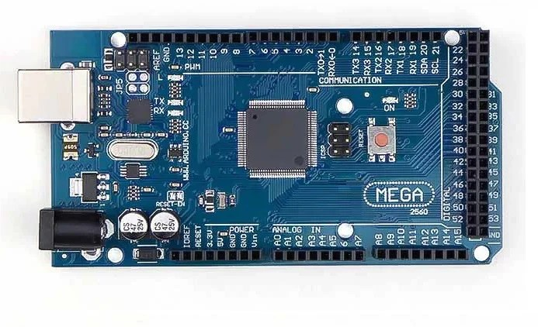

Figure 4‑2: ATmega328P Microcontroller

**2. Temperature Sensor**

The Temperature Sensor measures ambient temperature and sends real-time data to the MCU. Based on the readings, the system dynamically adjusts fan speed using Pulse Width Modulation (PWM) for DC fans or turns ON/OFF AC fans to maintain a comfortable temperature. If the temperature exceeds a certain threshold, the MCU can also trigger an alert or cooling response.

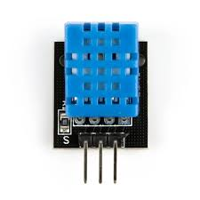

Figure 4‑3 : KY-026 Temperature Sensor Module

**3. Gas Sensor**

The Gas Sensor continuously monitors the concentration of hazardous gases in the environment. If a gas leak is detected, it triggers an emergency response by cutting off the main power supply, activating an alarm, and displaying a warning message. This helps prevent potential fire hazards and alerts occupants to take necessary action.

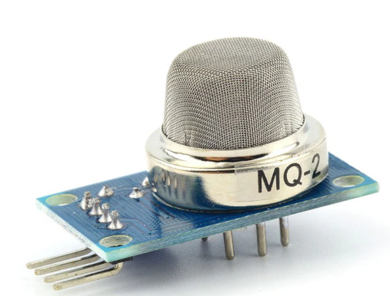

Figure 4‑4 : MQ-2 Gas/Smoke Sensor

**4. Liquid Crystal Display (LCD) with I2C adapter**

The **16×2 LCD module** in our **Smart Home Automation System** is used to display real-time system updates. Powered by a **5V supply**, it initially shows temperature, humidity, and gas levels. When a critical event occurs, such as **fire or gas leakage detection**, the LCD immediately updates to display an **alert message**, ensuring quick user awareness.

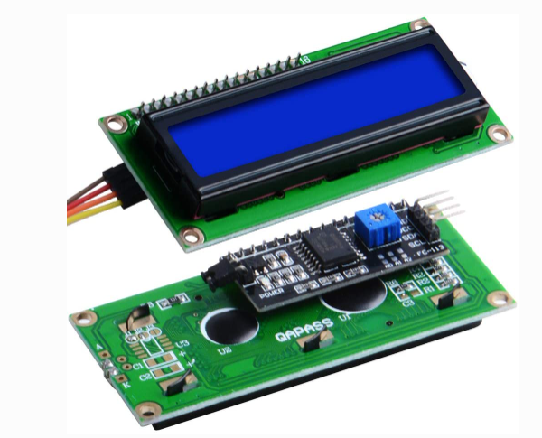

Figure 4‑5 : Liquid Crystal Display (LCD)

**5. Passive Buzzer**

The buzzer serves as a critical alert mechanism in the Smart Home Automation System. When gas is detected, the ATmega2560 microcontroller activates the buzzer, producing a high-decibel alarm to immediately notify occupants. Powered by 5V DC, the buzzer generates a sound in customized frequency, ensuring that the alarm is noticeable even in noisy environments. This feature enhances safety and rapid response in emergency situations.

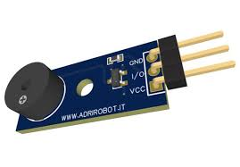

Figure 4‑6 : 5V Passive Buzzer

**6. 18650 Lithium-Ion Batteries**

The image shows 18650 lithium-ion rechargeable batteries with a capacity of 1800mAh and a nominal voltage of 3.7V. These batteries are commonly used in portable electronics, power banks, electric vehicles, and DIY projects due to their high energy density, lightweight design, and long cycle life. They provide a stable power supply and can be recharged multiple times, making them ideal for applications requiring efficient and reliable energy storage.



Figure 4‑7 : 18650 Lithium-Ion Batteries

**7. One-Channel Relay Module**

A **One-Channel Relay Module** is a crucial component used in automation systems to control electrical appliances. It acts as an electronic switch that can turn devices like fans, lights, or power supplies on and off. The module is typically controlled by a microcontroller or sensor, allowing for automation based on inputs such as sensor data. By enabling electrical devices to be controlled remotely or automatically, a one-channel relay module enhances safety, efficiency, and convenience in various applications like home automation, industrial control, and IoT systems.

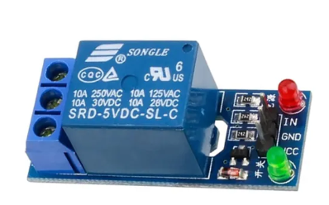

Figure 4‑8 : One-Channel Relay Module

**8. L298N Motor Driver Module**

The **L298N Motor Driver** is a commonly used dual H-bridge motor driver that allows for precise control of DC motors and stepper motors in various applications to control motors. In a smart home setup, the L298N is used to control the speed of a fan by adjusting the power supplied to its motor. By receiving PWM (Pulse Width Modulation) signals from the microcontroller the L298N modulates the voltage to the fan motor, controlling its speed. This enables automated fan speed adjustment based on temperature contributing to energy efficiency.

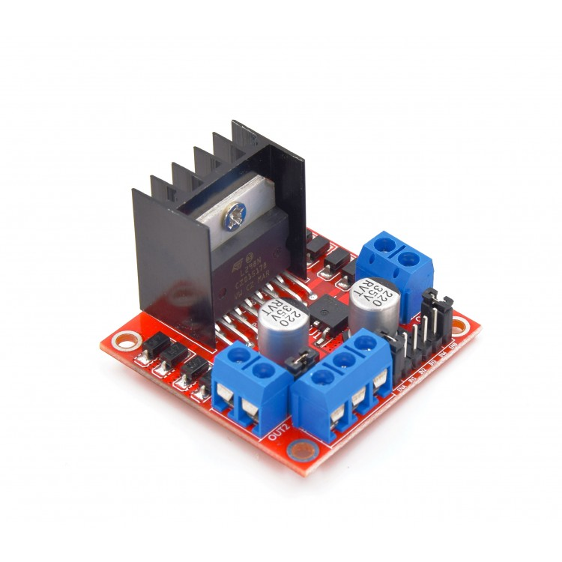

Figure 4‑9 : L298N Motor Driver Module

**9. LED Lights**

**LED (Light Emitting Diode)** is a semiconductor device that emits light when an electric current passes through it. In a smart home automation system, LED lights are used as Lights for smart home and for indicators.

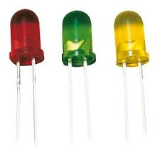

Figure 4‑10 : LED Lights

**10. 220Ω Resistors**

**220-ohm resistor** is a standard value resistor used to limit the current flowing through a circuit. In smart home automation, it is used in series with LEDs to prevent them from burning out due to excessive current. By providing the necessary resistance, a 220-ohm resistor ensures that the LED receives the appropriate voltage and current for safe and optimal performance.

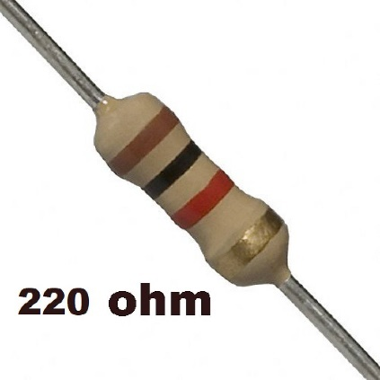

Figure 4‑11: 220Ω Resistors

# FINAL PRODUCT

## 5.1 Circuit diagram

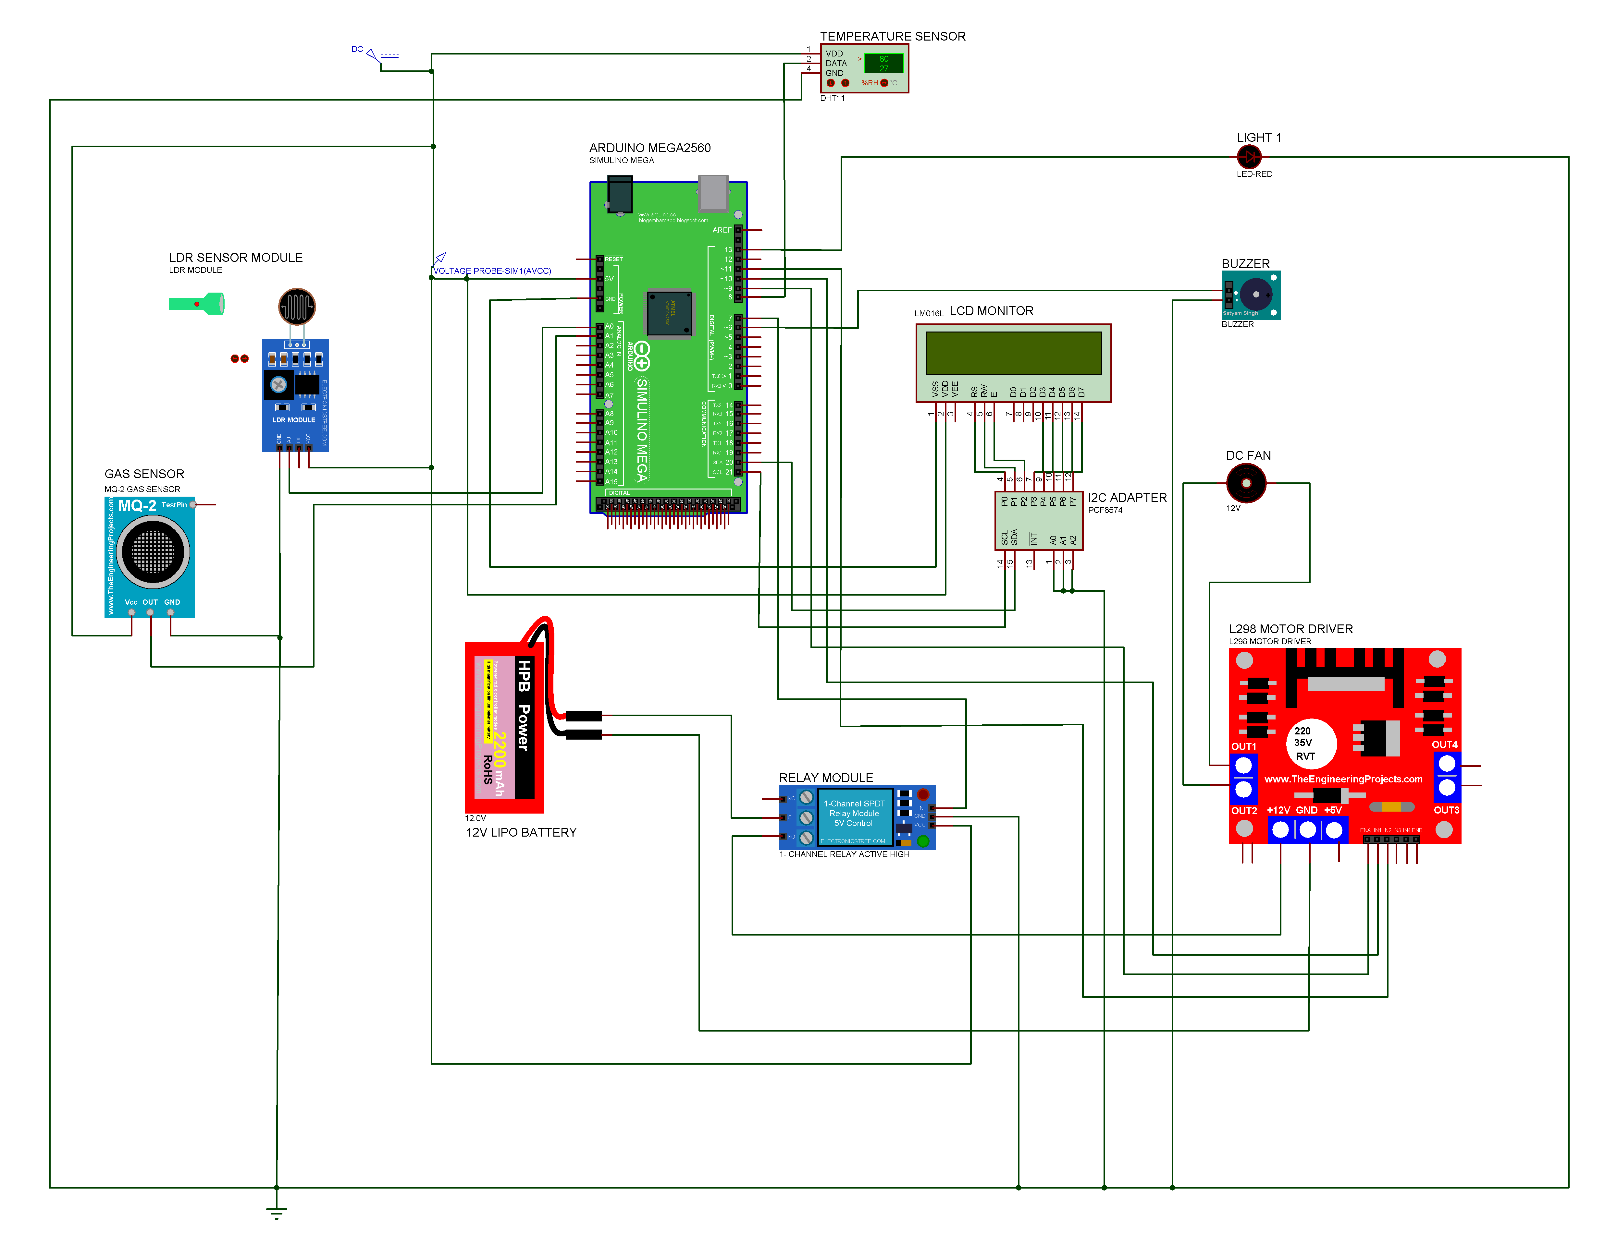

Figure 5‑1 : Circuit Diagram in Proteus

## 5.2 Flow chart

START

**Initialize the system**

Temperature sensor (KY 026)

Gas sensor (MQ-2)

LCD Display

Buzzer

**Read Sensor**

Read LDR sensor

Read temperature sensor

Read gas sensor

No

No

Gas leakage?

Yes

Yes

Show alert in LCD display and alert sound

Passive buzzer

Reset

Figure 5‑2: Flow chart

## 5.3 Results and setup

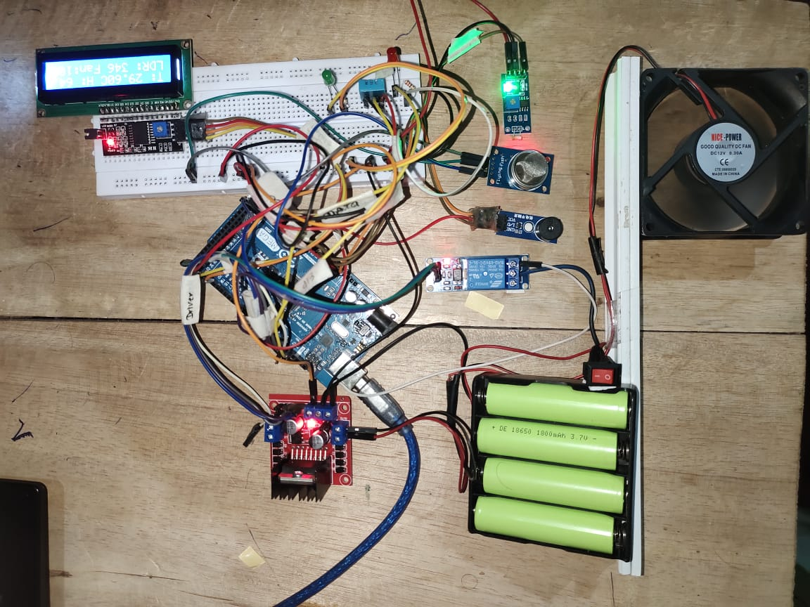

Figure 5‑3: Complete Project Layout

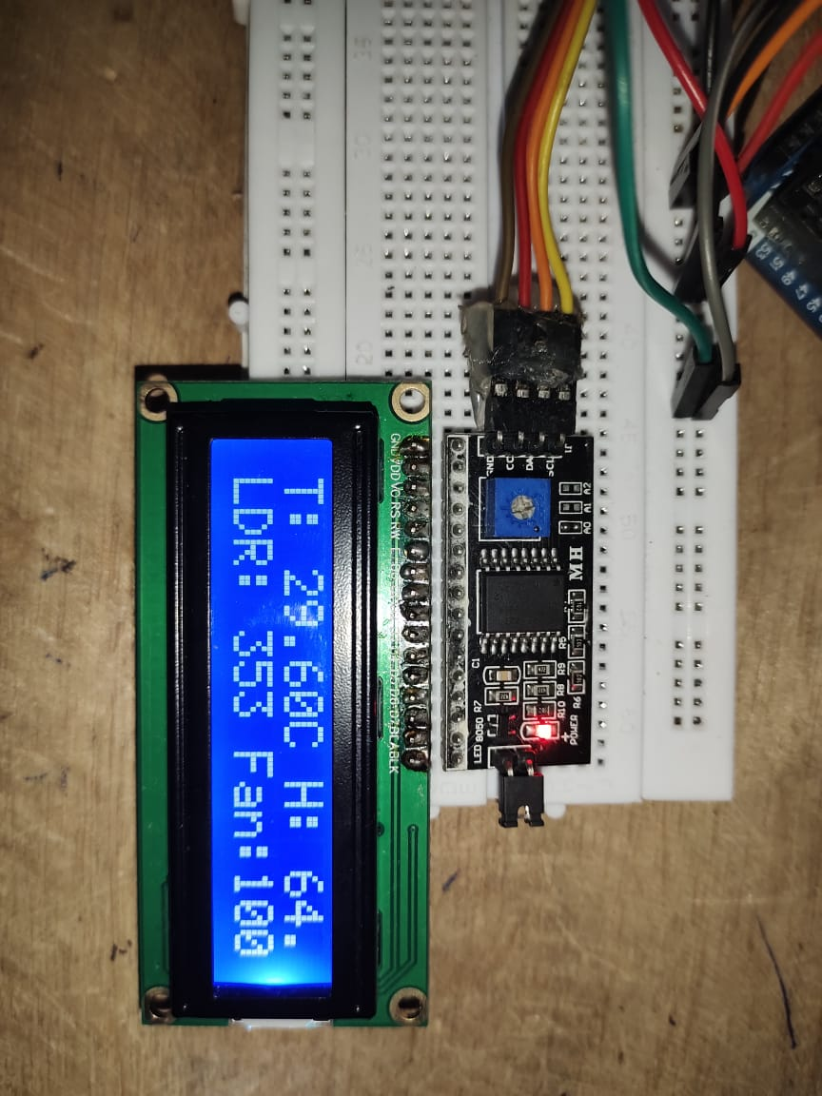

Figure 5‑4: LCD Display Output

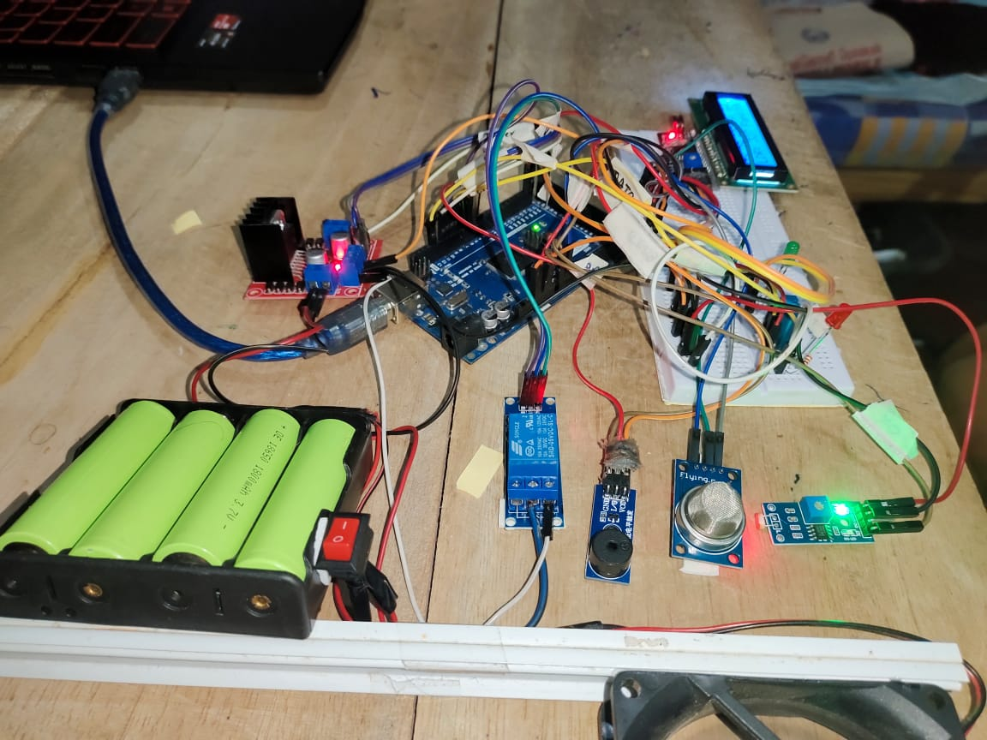

Figure 5‑5: Arduino-Based Circuit Assembly

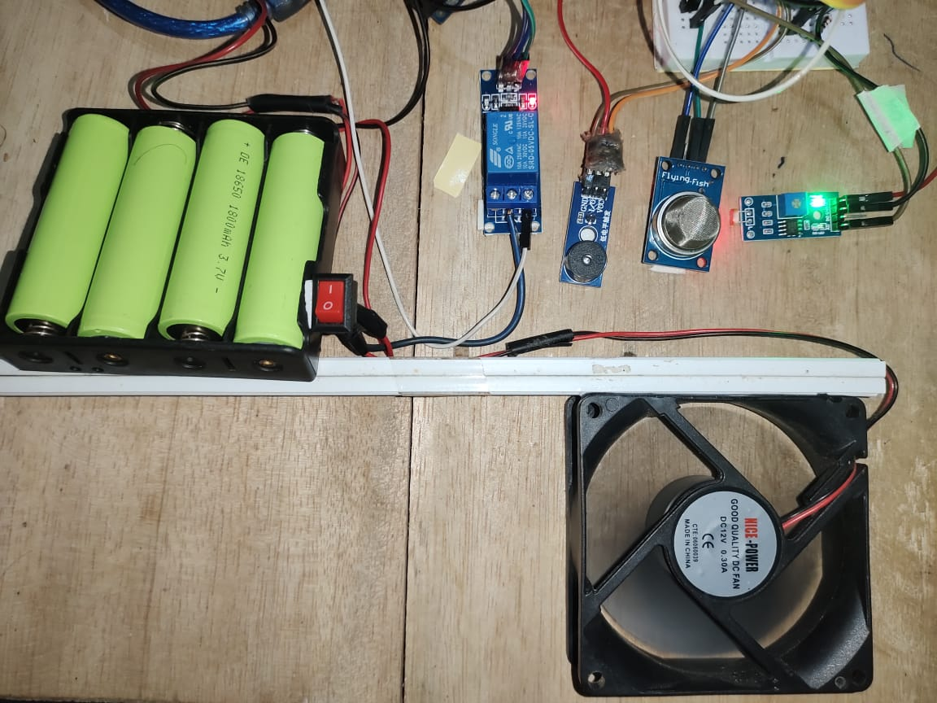

Figure 5‑6: A close-up view to the components

# DISCUSSION

## 6.1 Future Development Directions

Several areas for future development and enhancement have been identified to improve the system’s efficiency, usability, and scalability.

* **AI-Driven Adaptive Control**: Future iterations of the system could incorporate AI and machine learning algorithms to analyze user behavior and optimize energy consumption patterns.
* **Cloud-Based Monitoring and Control**: Integrating the system with cloud platforms would allow users to monitor and control their home automation remotely via a smartphone application or web dashboard.
* **Mobile Application Development**: A dedicated mobile application with an intuitive user interface should be developed to allow remote access, control, and real-time monitoring.
* **Integration with Smart Assistants**: Adding compatibility with voice assistants such as Alexa and Google Assistant would enhance user convenience and accessibility.
* **Improved Gas Leak Response Mechanism**: Further refinements could include automated emergency notifications to authorities or predefined contacts in case of a detected gas leak.
* **Energy Consumption Analytics**: Future versions could incorporate energy consumption tracking and analytics to help users optimize electricity usage and reduce costs.
* **Scalability for Multi-Home or Commercial Use**: Expanding the system for multi-room or commercial applications would improve its adoption beyond single-home automation.

# 7. REFERENCES

1. Tech Trends Shameer, “Smart Exhaust Fan Control using MQ2 Sensor & ESP8266,” *YouTube*, <https://www.youtube.com/watch?v=Zznk6X2xGwM>

(accessed Feb. 06, 2025).

1. “বিজ্ঞান প্রজেক্ট,” *বিজ্ঞান প্রজেক্ট*, 2024. <https://bigyanproject.com/en/projects/48-smart-home-project?srsltid=AfmBOooYc9yehsYEYA64RPidrDlze7sz3O-RXm5Y99byQ2-E51BEKSyr&utm_>(accessed Feb. 07, 2025).

‌

1. F. Sampayo, “Key Components for a Smart Home Automation System Explained,” *Schallertech*, Jan. 19, 2024. <https://schallertech.com/en/components-of-a-home-automation-system/?utm_>

(accessed Feb. 07, 2025).